1. Whole page article at "Philelephtheros" National Newspaper on World Stroke Day (29th of October)

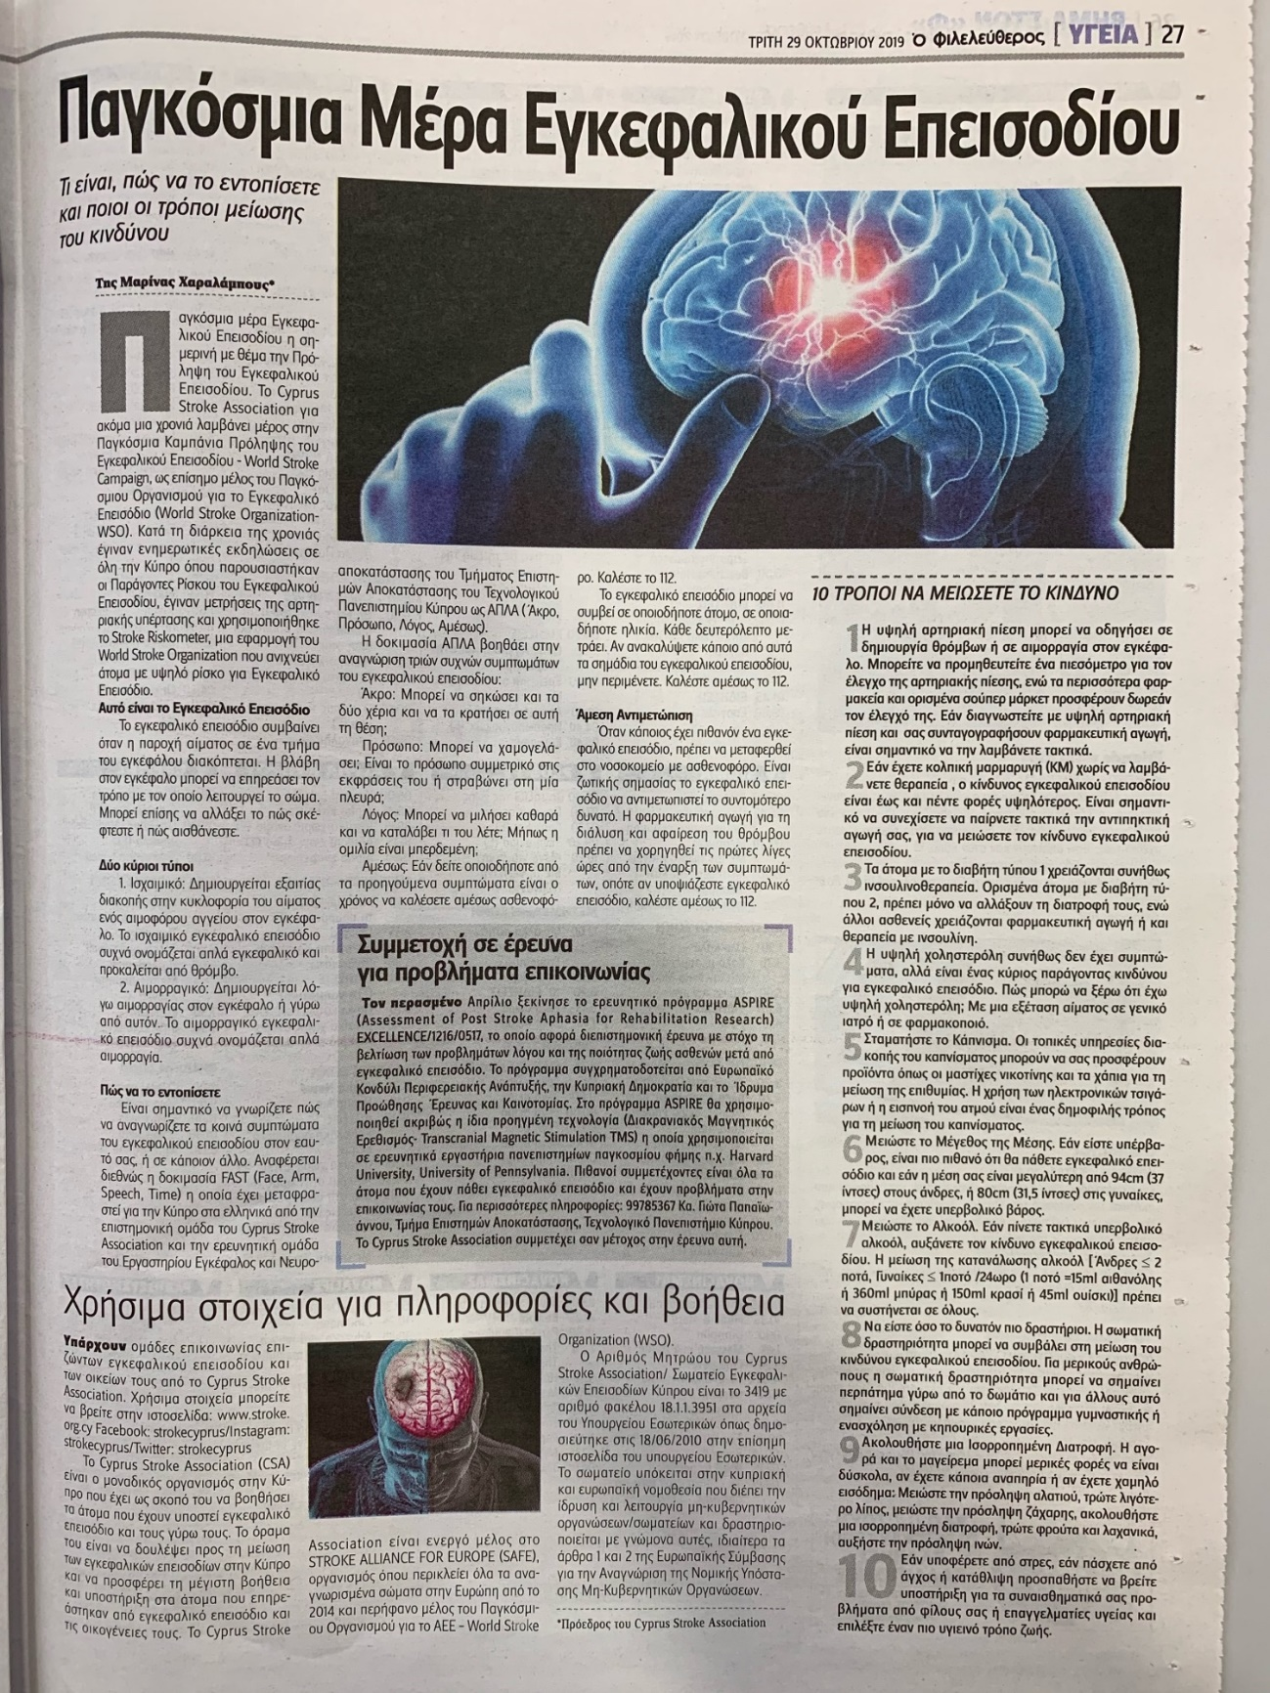

2. Live TV presentation of CSA activities and the ASPIRE project on Alpha TV- "Kalimera Show"  (29th of October)

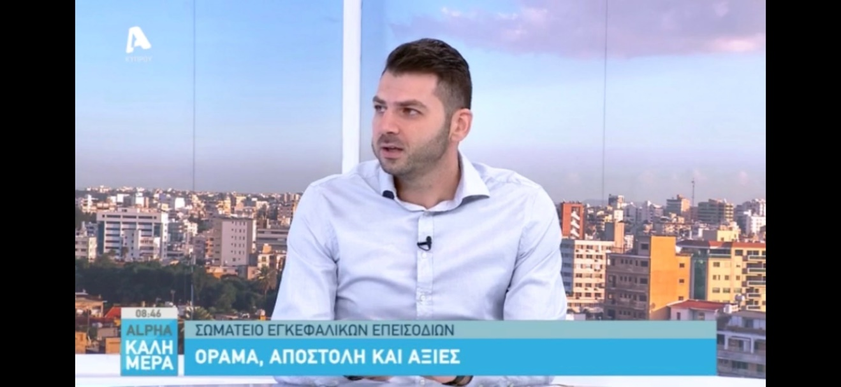

3. Poster Presentation at 5th European Neurorehabilitation Congress in Budapest, Hungary (9th-11th October)

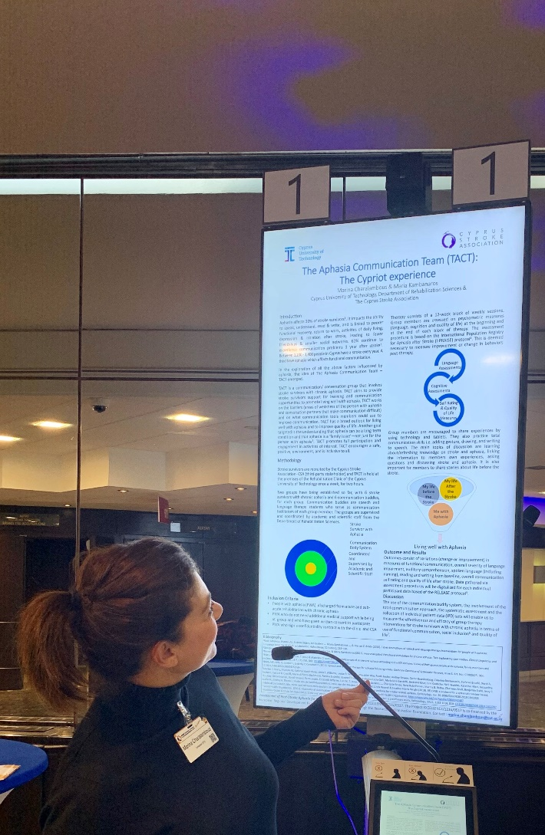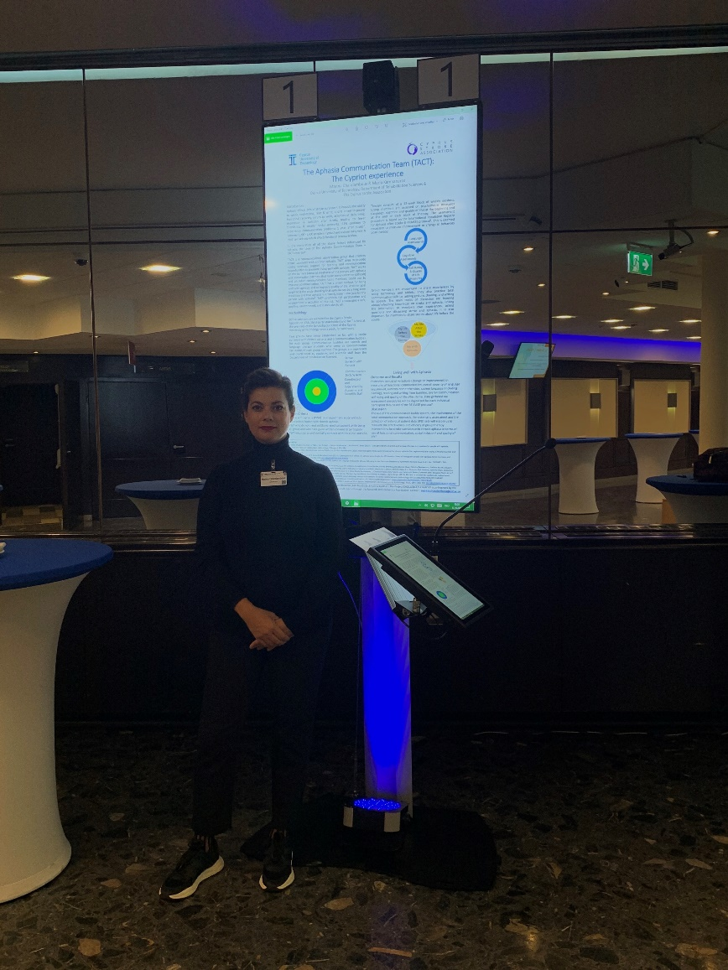

4. Dissemination of ASPIRE Poster via email (20th Sept)

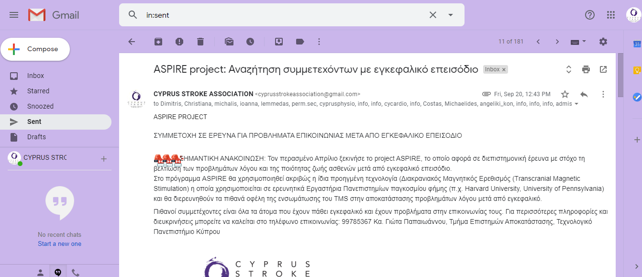

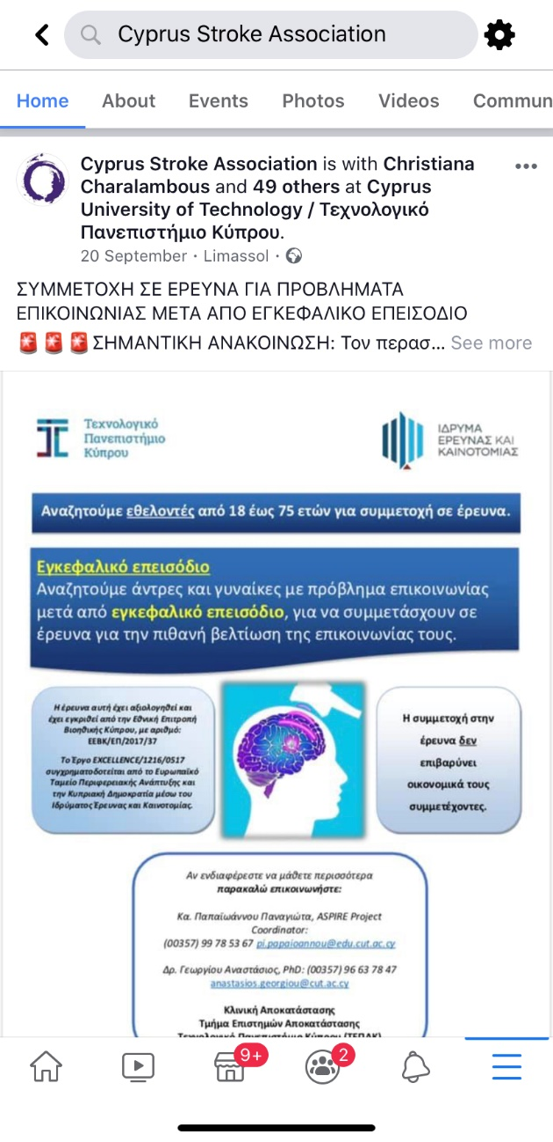

5. Dissemination of ASPIRE Poster via CSA Facebook page (20th Sept)

6. Students’ ASPIRE campaign

